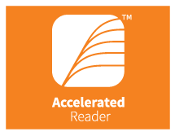

Accelerated Reader and the Teaching of Reading
At Marston Moreteyne School
“Accelerated Reader” is one of the many ways that we promote our love of books and teach Reading across the school. The information below outlines the different aspects of this and how it will be carried out in school.

Key Stage Two only then from January Year Two are introduced.

As the children have come back into school they have carried out a STAR Reading Assessment (Standardised Test for the Assessment of Reading). STAR Reading is used to determine your child’s reading level, it is a computer based reading assessment programme that uses adaptive technology to adjust to your child’s responses. If their answer is correct the difficulty level is increased. If they cannot answer the question then the level is reduced. The test uses multiple choice questions and lasts for 20 minutes.
This assessment then provides children with a personalised reading range called a ZPD
(Zone of Proximal Development). All of our reading books have been given a level and children have free rein to choose books from within the entire ZPD range. This starts at 0.2 and goes through to 13.5.
This could be within two or three different colour bands from our school banding system.
The books have been categorised according to difficulty of vocabulary, length of book and complexity of content. The ZPD range ensures that children will be challenged without causing frustration or loss of motivation.
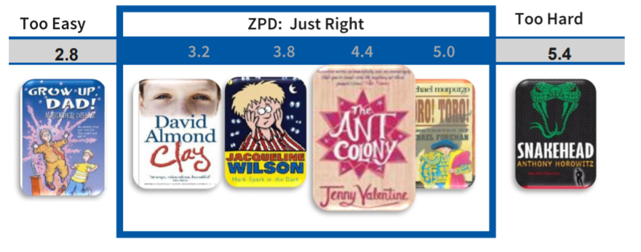
In this example a child has been given a ZPD range of 3.2 to 5.0

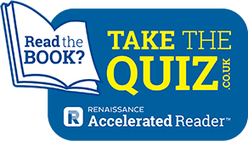

Accelerated Reader Quizzes-Years 1-4
Your child picks a book at their own level (from their ZPD) and reads it at their own pace. When finished, your child takes a short quiz on the computer or iPad in school. Passing the quiz is an indication that your child understood what was read. Accelerated Reader gives children and teachers feedback based on the quiz results, which the teacher then uses to help your child set goals and direct ongoing reading practice.
We look forward to sharing with you your child’s progress and attainment in Reading. Please speak to your child’s class teacher if you have any further questions. Thank you for your continued support with regular home reading practise, it makes a huge difference to your child’s progress.

