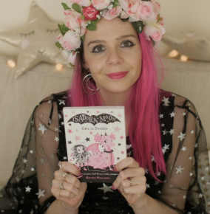
Outlined below are the spellings for each group this half term. Please find the correct spellings for the spelling group your child is in. It is expected that your child practices their spellings at least three times a week at home. Spellings are due on a Monday.

Muncaster Autumn Term One
Week 1  a cvc words | Week 2  i cvc words | Week 3  o cvc words | Week 4  e cvc words | Week 5  u cvc words | Week 6  b, d cvc words | Week 7  CCVC words
cat | bib | rod | bed | tub | bed | step
sad | lid | sob | red | mud | bib | spot
hat | pig | rob | peg | hug | bag | stab
bag | dig | jog | leg | jug | bat | skid
man | pin | mob | hen | sun | bin | crab
jam | bin | dot | pen | pup | dad | drum
van | rip | pot | ten | bus | dig | pram
tap | zip | fox | wet | hut | dot | cram

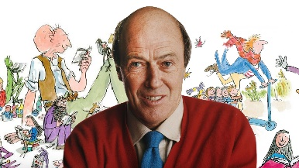
Dahl Autumn Term One
Week 2  y words | Week 3  igh words | Week 4  ow (like cow) words | Week 5  ow (like snow) words | Week 6  ir words | Week 7  ur words | Week 8  (practise during the half term)  Tricky words
cry | night | brown | snowman | skirt | church | your
drying | flight | crowd | grow | thirsty | purple | some
flying | sigh | town | yellow | shirt | nurse | there
reply | high | flower | elbow | birthday | burger | they
deny | mighty | howling | window | firstly | burning | have
sly | knight | allow | owner | dirty | turkey | little


Kinney Autumn Term One
Week 2  ch, sh, th | Week 3  Homophones | Week 4  nch | Week 5  se for /s/ | Week 6  ve for /v/ | Week 7  Plural ves | Week 8  Schwa (a)
three | two | pinch | house | have | scarf | ago
chair | too | crunch | please | love | scarves | away
share | blue | branch | because | glove | self | about
cheerless | blew | stench | sense | above | selves | again
thirsty | mail | lunchbox | mouse | twelve | wife | pasta
smooth | male | hunch | goose | starve | wives | avoid
loathe | die | drench | horse | solve | life | banana
thorny | dye | quench | dense | carve | lives | panda



Morpurgo Autumn Term One
Week 2  ch, sh, th | Week 3  Homophones | Week 4  nch | Week 5  se for /s/ | Week 6  ve for /v/ | Week 7  Plural ves | Week 8  Schwa (a)
thorny | die | crunchy | goose | twelve | scarves | pasta
loathe | dye | drench | geese | nerve | selves | avoid
cheerless | mail | quench | sparse | solve | wives | banana
benchmark | male | stench | corpse | carve | lives | panda
archway | stake | hunch | dense | starve | halves | comma
bashful | steak | lunchbox | horse | groove | loaves | hexagon
faithful | waste | scrunch | increase | curve | hooves | magazine
parchment | waist | flinch | promise | deserve | leaves | husband
smooth | thyme | wrench | collapse | mauve | knives | embarrass
sushi | time | pinched | pulse | involve | wolves | private
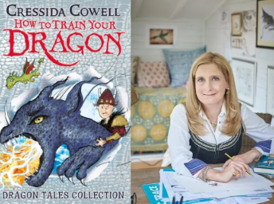

Cowell Autumn Term One
Week 2  ch, sh, th | Week 3  Homophones | Week 4  nch | Week 5  se for /s/ | Week 6  ve for /v/ | Week 7  Plural ves | Week 8  Schwa (a)
benchmark | waste | scrunch | increase | curve | hooves | anagram
archway | waist | quench | promise | deserve | leaves | husband
bashful | thyme | flinch | reverse | evolve | knives | harass
faithful | time | wrench | pulse | involve | wolves | private
squashed | groan | crunchy | nonsense | conserve | shelves | magazine
parchment | grown | pinched | collapse | mauve | halves | embarrass
gibberish | air | launch | immense | eavesdrop | calves | exclamation
mythical | heir | unclench | lighthouse | dissolve | thieves | paragraph
achieve | wait | henchmen | converse | observe | ourselves | announcement
anchovy | weight | enchantment | suspense | retrieve | dwarves | entrance

